Deriving Mathematical Models for Terrain Slope

Richard M Bradford
Rockwell Collins
November 2012

For the purpose of characterizing the terrain context for a ground vehicle, we wish to derive a mathematical model that expresses the likelihood of traversing from one degree of ground slope to another. Based on review of relevant literature, as well as original research in collaboration with our partners at BAE, we have developed two classes of models that appear to provide useful results. These are: (1) a Gaussian-Markov model (also related to models based on an Ornstein-Uhlenbeck process), and (2) a model based on a maximum entropy distribution. In the following sections we explain each of these models and provide a comparative evaluation.

Gauss-Markov Model

We use, as a basis for the Gauss-Markov model, a related model derived in (Kuchar, 2001). In that paper, Kuchar derives a Markov chain model for expressing probabilities of given changes in elevation. The probability of transitioning, at step $n$ to step $n+1$, from a starting altitude bin $y_{n}$ to altitude bin $y_{n+1}$ is given by Kuchar’s equation (10):

$$p_{y_{n+1}{,y}_{n}}\left(n\right)=\int_{y_{n+1}-h/2}^{y_{n+1}+h/2}{\frac{1}{\sqrt{2πσ^{2}\left(1-e^{-2β}\right)}}} × e^{\frac{-{\left(y-e^{-β}y_{n}\right)}^{2}}{2σ^{2}\left(1-e^{-2β}\right)}} dy$$

where $h$ is the height of an altitude bin, and $σ$ and $β$ are autocorrelation parameters. Kuchar derived values for these parameters by fitting the probability function to a database of actual terrain altitude samples obtained from the U.S. Geological Survey for the Great Plains and Rocky Mountain region between 102 and 112 degrees West longitude and 32 and 49 degrees North latitude. Kuchar provides a table (Table 2) of values for the parameters for terrain categories of Smooth, Moderately smooth, Moderate, Moderately steep, and Steep.

The integrand in Kuchar’s equation (10) is a probability density function (pdf) for a random variable that is normally distributed with mean $e^{-β}y_{n}$ and standard deviation$σ\sqrt{1-e^{-2β}}$.

Paul Pukite of BAE has argued (2012) that a Normal distribution of elevation changes arises as the result of an Ornstein-Uhlenbeck process. In this case, the most likely elevation change is zero, and the probability density function for an absolute change z is
$$p\left(z|F\right)=\frac{1}{\sqrt{πF}}e^{{-z^{2}}/{4F}}$$
where F is a parameter that captures the variance. We can derive the maximum likelihood estimate for F as follows. For ease of calculation we will work with the log likelihood, which, for a set of observations $z_{i}, i=1,…, n$ is
$$\ln{L}\left(F|z\right)=\sum_{i=1}^{n}{ln\left(\frac{1}{\sqrt{πF}}e^{{-{z_{i}}^{2}}/{4F}}\right)}=\sum_{i=1}^{n}{\left[ln\left(\frac{1}{\sqrt{πF}}\right)-\frac{z_{i}^{2}}{4F}\right]}$$

Differentiating this with respect to F, and setting the derivative equal to zero implies

$F=\frac{\sum_{i=1}^{n}{z_{i}^{2}}}{2n}$.

With this estimate of the parameter F, we can estimate probabilities of given changes in altitude for a given distance of horizontal travel. Given the above model, with the relevant range of altitudes divided into bins of height h, the probability of an elevation change from the current bin to one k bins higher is given by
$$\text{Φ}\left(\left(k+\frac{1}{2}\right)h,2F\right)-Φ\left(\left(k-\frac{1}{2}\right)h,2F\right)$$

where $Φ\left(μ,σ^{2}\right)$ is the cumulative distribution function for a normally distributed random variable with mean $μ$ and variance $σ^{2}$. A similar expression holds for the probability of moving down by k bins. In the next section we describe an analogous derivation based on maximum entropy. The subsequent section then explains how to translate these probability distributions over elevation changes into probability distributions of slopes.

Maximum-Entropy Model
Essentially, the maximum entropy principle states that, when making inferences about a probability distribution based on incomplete information, one should arrive at the probability distribution that has maximum entropy among those permitted by the observed information. Jaynes (1982) explains the motivation for this principle by showing that the permissible distributions are strongly concentrated near the one having maximum entropy – in other words, “distributions with appreciably lower entropy than the maximum permitted by our data are atypical of those allowed by the data.” For terrain elevation, it is clear that the absolute value of a change in elevation must be nonnegative; furthermore it is reasonable to assume we can obtain data on average elevation changes for a given region. For a nonnegative random variable with a given expected value, the maximum entropy distribution is exponential:
$$p\left(z|F\right)=\frac{1}{F}e^{{-z}/F}$$

As before, we can derive the maximum likelihood estimate for F as follows. For ease of calculation we will work with the log likelihood, which, for a set of observations $z_{i}, i=1,…, n$ is
$$\ln{L}\left(F|z\right)=\sum_{i=1}^{n}{ln\left(\frac{1}{F}e^{{-z_{i}}/F}\right)}=\sum_{i=1}^{n}{\left[ln\left(\frac{1}{F}\right)-\frac{z_{i}}{F}\right]}$$
Differentiating this with respect to F, and setting the derivative equal to zero implies

$F=\frac{\sum_{i=1}^{n}{z_{i}}}{n}$.

Given this model, with the relevant range of altitudes divided into bins of height h, the probability of an elevation change from the current bin to one k bins higher is given by
$\frac{1}{2}\int_{\left(k-\frac{1}{2}\right)h}^{\left(k+\frac{1}{2}\right)h}{ \frac{1}{F}e^{{-z}/F}}dz=\frac{1}{2}\left(e^{{-\left(k-\frac{1}{2}\right)h}/F}-e^{-{\left(k+\frac{1}{2}\right)h}/F}\right)$.

An analogous expression holds for the probability of moving down by k bins.

Converting to Distributions of Slopes

The probabilities of given changes in elevation translate, using a known step size (for example, 300 feet as in Kuchar’s model), to a probability distribution of the slope at the given elevation. Note that slope is a fundamentally different attribute of the terrain from elevation, in that slope depends on the orientation from a given spot, whereas elevation does not. For now we ignore this issue by assuming that the distribution of slopes from each point matches the overall distribution of slopes from all points at the same altitude.

For a given elevation and slope, continued travel along the direction corresponding to that slope will lead to a new elevation, based on the slope and the step size. The new elevation will have a distribution of slopes derivable from the altitude transition probabilities associated with that new elevation. We can think of this distribution of slopes as representing the probability of observing each given slope after the transition, based on the step size and the altitude prior to the transition.

Mathematically, we can express this as follows. Let$∆$ be the step size. Let $y_{n}$ be the elevation (or altitude) prior to the transition and let $s_{n}$ be the slope prior to the transition. Then
$$p_{s_{n+1}{,s}_{n}}\left(n\right)=p_{y_{n+2}{,y}_{n+1}}\left(n+1\right)$$
where $y_{n+1}= y_{n}+∆∙s_{n}$and $y_{n+2}= y_{n+1}+∆∙s_{n+1}$.

Working with a step size of $∆$ = 100 meters allows for additional simplification. For altitude bins of height h in meters, the slope, or grade, as a percent, in going from bin $b$ to bin $b'$ is
$\left(b^{'}-b\right)∙h$.

Evaluation

Based on analysis of elevation data for the continental United States, we have found that in most areas the Maximum Entropy model gives a better fit to the terrain than the Gauss-Markov model, although there are some where the Gauss-Markov is better (Pukite, 2012). Figures 1 and 2, shown below give details.
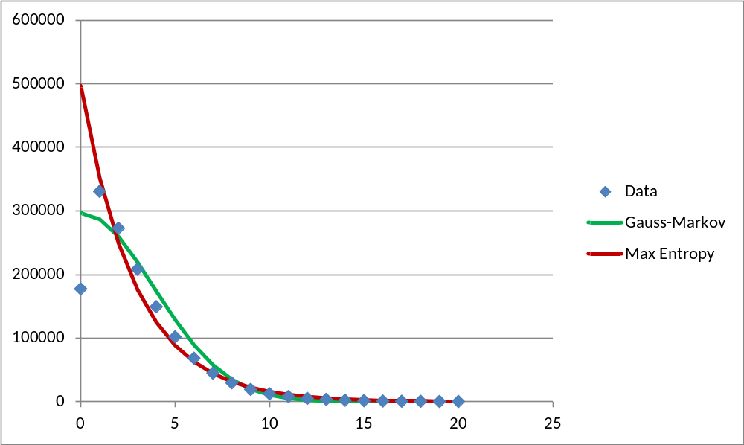
Figure 1. In this data set, taken from near Andalusia, Alabama, the Gauss-Markov model gives a better fit than the Maximum Entropy model. The X axis gives the vertical deviation, in meters, for 100m of horizontal travel, while the Y axis gives the number of observations with the given deviation.

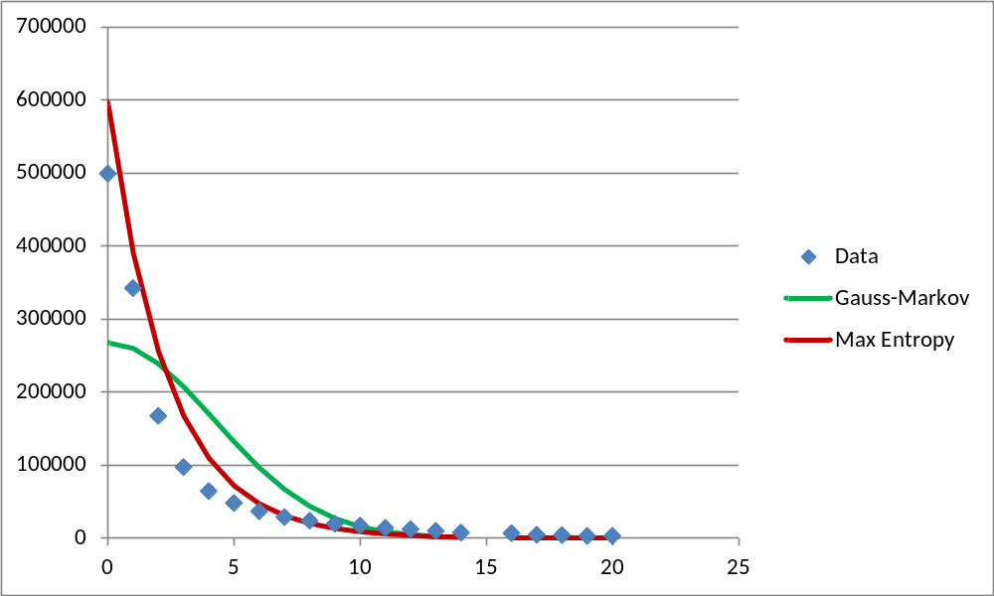
Figure 2. In this data set, taken from the Eau Claire West quadrangle in southeastern Minnesota, the Maximum Entropy model gives a better fit than the Gauss-Markov model. The X axis gives the vertical deviation, in meters, for 100m of horizontal travel, while the Y axis gives the number of observations with the given deviation.

References

Jaynes, E. T. “On the Rationale of Maximum-Entropy Methods,” Proceedings of the IEEE 70(9): 939-952, September 1982.

Kuchar, J. K. “Markov Model of Terrain for Evaluation of Ground Proximity Warning System Thresholds,” J. Guidance, Control, and Dynamics 24(3): 428-435, May-June 2001.

Pukite, P., BAE Systems, Inc., private communication, November 2012.

